1- No need to switch the module to serial port mode (keep it in I2C mode).
2- Connect the converter to PC and open the upgrade tool.
3-Choose the serial port number and click 'CONNECT'. Then open the bin file
4- Connect the Lidar to the converter. Note: connect only the GND, RX and TX and leave the VCC unconnected at this stage
5- Click 'DOWNLOAD' on the panel of the upgrade tool and conncet the VCC of the Lidar to the converter within 10s.

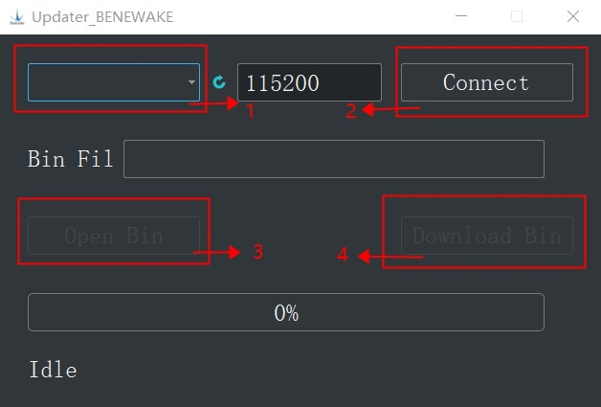

When it is done, you may check the version number of the firmware.
Don't forget to power off the LiDAR after the total upgrading method

